For data communication of information and messages we use telephone and postal communication systems
Data and information from one computer system can be transmitted to other systems across geographical areas
The methods include electrical signals carried along a medium(conductor, optical signals along an optical fibers and electromagnetic wave)

The following are the basic requirements for working of a communication system.
- A sender (source) which creates the message to be transmitted.
- A medium that carries the message.
- Language used for communication
- A receiver (sink) which receives the message.
A computer network is a group of computer system and other computing hardware devices that are linked together through communicating channel. Which facilitate communication, resource sharing.
Each computer can be called as node, so networking in another term is interconnection of two or more nodes through transmission medium.
Computers can be connected via transmission medium like copper wires, optical fiber, communication satellite, radio links (Microware) etc.
Importance Of Networking
As N/W provides a platform for communication users and information, uses/ importance as follows:
- Resource Sharing
- Information Sharing
- As a communication medium
- Centralize administration and support
- Back-up and Support
Regardless of So many benefits of networking, still there are some Disadvantages we could discuss over.
- Expensive-(Setup resources and additional hardware)
- Security of data
- Needs special technical knowledge
- Venerable to computer Virus and Malware.
Data Communication 4 Basic Terms
Data: A collection of facts in raw forms that become information after processing.
Signals: Electric or electromagnetic encoding of data.
Signaling: Propagation of signals across a communication medium.
Transmission: Communication of data achieved by the processing of signals.
Data Transmission Media
The data is sent from one computer to another over a transmission medium, grouped as guided and unguided medium
1. Guided media
- Physical Transmission Path
- Copper wire & Optical fiber are most commonly used
- Copper wire transmit as electric signal while optical one transmit as light signal.
- Copper wire offer low resistance to current signal, fascinating longer distance transmission
- Eg: Twisted pair cable, Co-axial cable, optical fiber etc.
2. Unguided media
- Data signals are not bounded by a fixed channel to follow.
- The data signals are transmitted by air.
- Eg: Radio, microwave, and satellite transmissions
Wire Pair/Twisted Pair
Wire pairs are commonly used in local telephone Communication and for short distance digital data communication.
They are usually made up of copper and the pair of wires is twisted together
Pairs of copper wires coated with an insulating material like plastic or Teflont
Wisting of wires reduces electromagnetic interference from external sources
Twisted pair is of two kinds—Shielded Twisted Pair (STP), and Unshielded Twisted Pair (UTP).
Data transmission speed is normally 9600 bits per second in a distance of 100 meter.
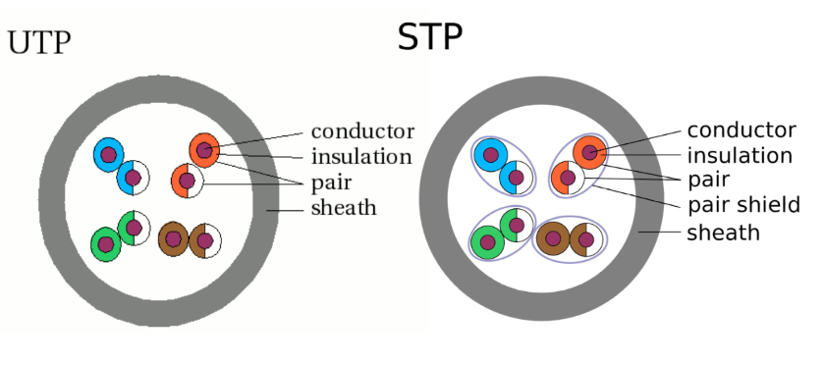Coaxial Cable
They consist of a central copper wire surrounded by an insulation over which copper mesh is placed.
The inner conductor, insulator, and the outer conductor are wrapped in a sheath of Teflon or PVC.
Inner wire is used for signal transmission while outer conductor is used for grounding purpose
Insulator provides resistance to external electromagnetic filed and signal is transmitted without power loss.
Thickness of coaxial cable affect the amount of data it can transfer.
They are used for long distance telephone lines and local area network for their noise immunity and faster data transfer.
The commonly used coaxial cable is 10 base 2 that transmits over a distance of 185 m, and 10 base 5 that transmits over a distance of 500 m.
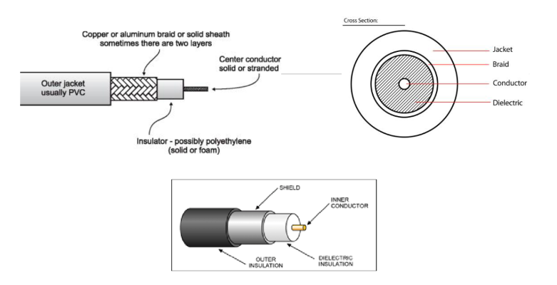
Knowledge Based:
Unshielded Twisted Pair (UTP)
UTP comes in several categories that are based on the number of twists in the wires, the diameter of the wires and the material used in the wires.
Category 3 is the wiring used primarily for telephone connections.
Category 5e and Category 6 are currently the most common Ethernet cables used.
Categories of UTP
CAT 1 | CAT 2 | CAT 3 | CAT 4 | CAT 5
16 Mhz Bandwidth | 20 Mhz Bandwidth | 100 Mhz Bandwidth | 150 Mhz Bandwidth | 250 Mhz Bandwidth
11.5 dB Attenuation | 7.5 dB Attenuation | 24.0 dB Attenuation | 24.0 dB Attenuation | 19.8 dB Attenuation
100 ohms Impedance | 100 ohms Impedance | 100 ohms Impedance | 100 ohms Impedance | 100 ohms Impedance
Voice applications | Data Transmission | High-speed Data Transmission | Transmit High-Speed Data | Transmit High-Speed Data
& 10baseT (10Mbps) Ethernet | Used in 10baseT (10Mbps) Ethernet | 10BaseT (10 Mbps) Ethernet & Fast Ethernet (100 Mbps) | Used in Fast Ethernet (100 Mbps), Gigabit Ethernet (1000 Mbps) & 155 Mbps ATM | Used in Gigabit Ethernet (1000 Mbps) & 10 Gig Ethernet (10000 Mbps)
Fiber Optics/Optical Fiber
Optical fibers use light to send information through the optical medium.
It uses the principal of total internal reflection.
Modulated light transmissions are used to transmit the signal.
It consist of
- Core: optical fiber conductor (glass) that transmits light
- Cladding: an optical material that surrounds the core to prevent any light from escaping the core3)
- Jacket:outer covering made of plastic to protect the fiber fromdamage.
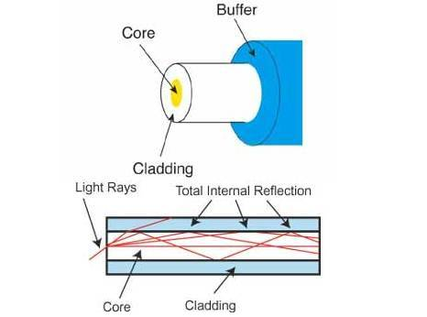
Data Transmission And Data Networking
Data transmission: Transmitting digital or analog data over a communication medium to one or more devices.
At physical level; it involves the hardware that handle individual bits and encode bits in signals. And transmit via medium
Data Transmission Network tropology:
point-to-point, point-to-multipoint, or multipoint-to-multipoint(Mesh)
If a large number of computers need to interact with each other, point to point communication will require direct link between all the computers.
- More expensive
- Not practical
Also, Data doesn’t transmit data all the time, which will result in the communication medium will be ideal. (Waste of resources)
Computer Network; it provide convenient interface that handles sending of multiple bytes of data across the network instead of handling data transmission at physical level.
POINT TO POINT COMMUNICATION | MULTIPOINT COMMUNICATION
Point to point communication means the channel is shared between two devices. | Multipoint Communication means the channel is shared among multiple devices or nodes
In this communication, There is dedicated link between two nodes. | In this communication, link is provided all times for share the connection among nodes.
In this communication, the entire capacity is reserved between these connected two devices. | In this communication, the entire capacity is depend on the quick sharing.
In point-to-point connections, the smallest distance is most important to reach the receiver. | In Multi-point connections, the smallest distance is not important to reach the receiver.
Point-to-point communication provides security and privacy because communication channel is not shared. | Multi-point communication does not provides security and privacy because communication channel is shared.
In this communication, there is one transmitter and one receiver. | In this communication, there is one transmitter and many receivers.
Switching
Switching is the process of transmitting data packets from the source to the destination through a number of intermediate network nodes.
Each node controls or Route/Switches data packets to the next node towards the destination
It allows different users, fair access to the shared communication medium
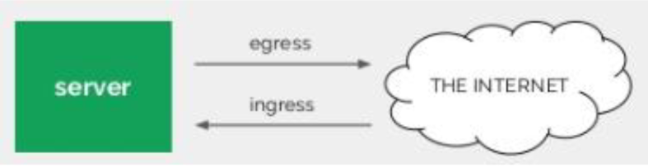
When data comes on a node it is called ingress, and when data goes out of a node it is called egress.
Switching methods are connection oriented switching and connectionless switching.
Switching Techniques
1. Circuit Switching
- Connection Oriented N/W switching technique
- Dedicated route is established between the source and the destination
- Full Channel bandwidth is available for communication during the communication session.
- Commonly used in telephone communication
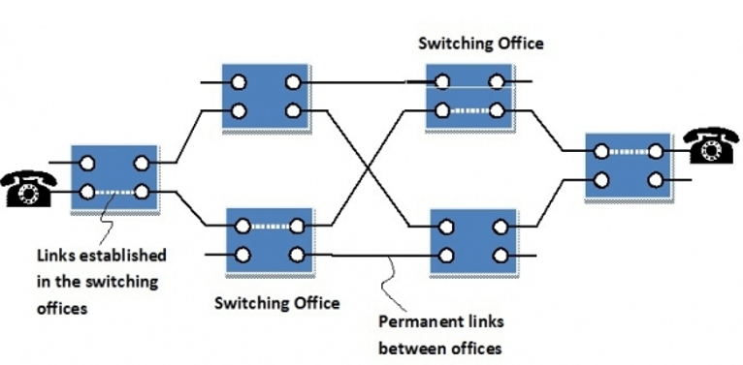
Advantages | Disadvantages
It is suitable for long continuous transmission, since a continuous transmission route is established, that remains throughout the conversation. | Circuit switching establishes a dedicated connection between the end parties. This dedicated connection cannot be used for transmitting any other data, even if the data load is very low.
The dedicated path ensures a steady data rate of communication. | underutilization of system resources
No intermediate delays are found once the circuit is established. | As it’s the dedicated channel, Cannot be used for other connections
suitable for real time communication of both voice and data transmission | Time required to establish connection may be high.
2. Message Switching
Message switching is a connectionless network switching technique where the entire message is routed from the source node to the destination node, one hop at a time
It uses the ‘store and forward’ mechanism at each intermediate node during switching
Message switching treats each message as an individual unit. Before sending the message, the sender node adds the destination address to the message.
Then delivered to the next intermediate switching node
intermediate node stores the message checks for transmission errors, inspects the destination address and then delivers it to the next node.
If intermediate switching node is busy, it delay the switching until resource is available.‘store and forward’
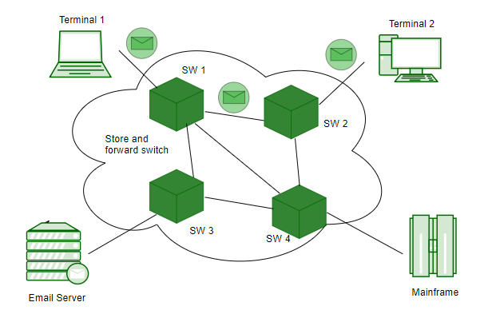
Advantage | Disadvantage
Sharing of communication channels ensures better bandwidth utilization | In order to store many messages of unlimited sizes, each intermediate switching node requires large storage capacity
reduces network congestion due to store and forward method. | Store and forward method introduces delay at each switching node
Broadcasting messages requires much less bandwidth than circuit switching. | Unsuitable for real time applications,because of delay, store and forward mechanism
Messages of unlimited sizes can be sent
No needto deal with out of order packets or lost packets as in packet switching
3. Packet Switching
Connectionless Network Switching Technique
the message is divided and grouped into a number of units called packets
Packets individually routed from the source to the destination.
There is no need to establish a dedicated circuit for communication.
Process
Each packet has two parts: a header and a payload.
The header contains the addressing information of the packet.
Used by the intermediate routers to direct it towards its destination.
The payload carries the actual data.
Based on header information, Packet is transmitted as soon as it is available in a node
packets of a message are not routed via the same path, they are transmitted as per the path available.
When packets of a message arrive to destination they are not in order
Destination retrieve the original message by reordering the received packets
A packet is transmitted as soon as it is available in a node, based upon its header information
Packets A,B,C and D follow different routes from sender to receiver.
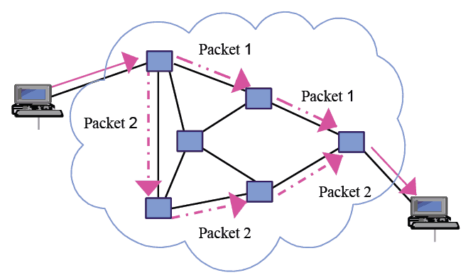
Advantage | Disadvantage
Delay in delivery of packets is less, since packets are sent as soon as they are available | unsuitable for applications that cannot afford delays in communication like high quality voice calls
Don’t require massive storage, since they don’t have to store the entire messages before forwarding them to the next node. | high installation costs
Data delivery can continue even if some parts of the network faces link failure. Packets can be routed via other paths. | Network problems may introduce errors in packets, delay in delivery of packets or loss of packets. If not properly handled, this may lead to loss of critical information
use of the same channel by multiple users. | Requires high skilled manpower, complex protocols for delivery.
better bandwidth usage

Computer Network
It is an interconnection of two or more computers that are able to exchange information.
Connection establish via any data transmission medium or link
Computer Networks can be categorized depending on
- Size of Network;area over which the network is spread
- Transmission Technology;transmission media and transmission protocols
- Network Tropology; arrangement / shape of network
Types Of Networks
- LAN (Local Area Network)
- MAN (Metropolitan Area Network)
- WAN (Wide Area Network)
1. Local Area Network (LAN)
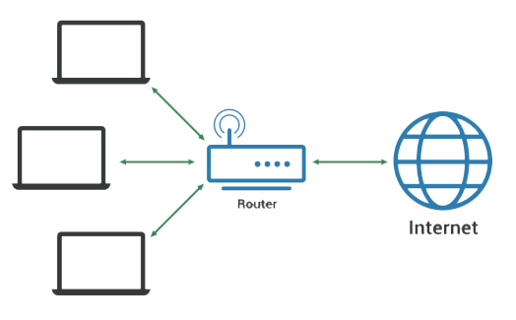
widely used for local communication
LAN connects computers in a small area like a room, building, office or a campus spread up to a few kilometers
LAN runs at a speed of 10 Mbps to 100 Mbps and has low delays
A LAN based on WiFiwireless network technology is called Wireless Local Area Network (WLAN)
It is a privately owned networks, with a purpose to share resources and to exchange information
Hardware resources that can be easily shared over the LAN network include printer, fax machines, modems, memory space, etc
2. Metropolitan Area Network (MAN)
It is a network spread over a city, college campus or a small region
Typical Example is Cable Television and Local ISP.
MAN is larger than a LAN and typically spread over several kilometers.
MAN is also interconnection of several LAN spread over a city.
Objective of MAN is to share hardware and software resources, thereby decreasing infrastructure costs
MAN are connected using coaxial cables or fiber optic cables
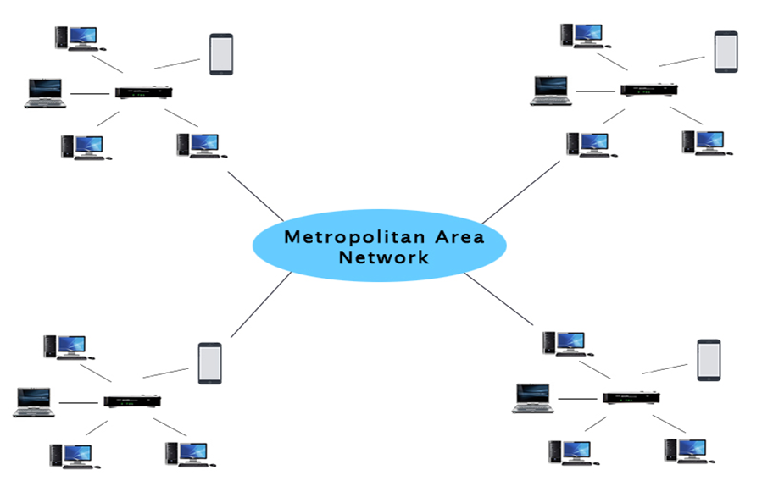
3. Wide Area Network (WAN)
connects computers over long distances like cities, countries, continents or worldwide
WAN is typically a network of many LANs, MANs and WANs
WAN uses telephone lines, satellite link, and radio link to connect
Internet is a common example of WAN
